**Input and Output Problems (String and Numeric Variables)**

**Task 3:**

**Plan:**

1. Validation: check that variable carbon is an integer, if not display error message and ask to enter again.
2. Define viable hydrogen and calculate number of hydrogen.
3. Define variable chemical and calculate chemical.
4. Define variable mass and calculate atoms mass.
5. Out mass and chemical variables

**Pseudocode:**

Valid = True

While valid <> True:

Try:

Carbon = input as integer ("Enter the number of Carbon atoms? ")

Valid = False

Except:

Print ("Not a valid number of carbon atoms!")

Hydrogen = (carbon*2)+2

Chemical = “C” + (carbon) as string + “H” + (hydrogen) as string

Mass = 12*carbon + 1*hydrogen

**variables table:**

|  |  |  |
| --- | --- | --- |
| Variable name | Data type | content |
| Valid | Boolean | True |
| Carbon | Integer | Stores input from user |
| Hydrogen | Integer | (carbon*2)+2 |
| Chemical | String | “C”+carbon+”H”+hydrogen |
| Mass | Integer | 12*carbon+1*hydrogen |

**Screenshot evidence:**

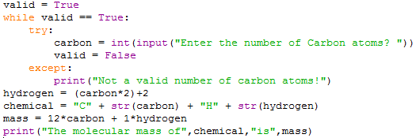

**Sample run (Output):**

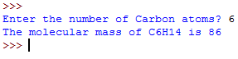

**Flow charts:**

Start

Output (chemical, mass)

mass = 12*carbon + 1*hydrogen

Chemical = “C”+carbon+”H”+hydrogen

hydrogen = (carbon*2)+2

Yes

Output error message

No

Is carbon an integer?

Carbon = input as intiger

Valid = True